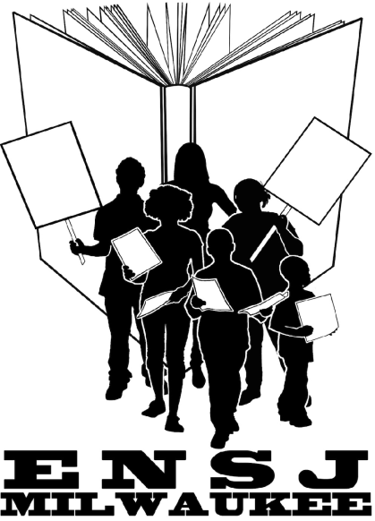
Dear (Principal’s Name),

ENSJ’s 10th Annual Teaching Conference is coming up in April. What is ENSJ you ask…? Educators’ Network for Social Justice, of course! ENSJ’s annual conference helps to promote culturally responsive teaching practices. I know you aspire to offer your teachers opportunities to learn more about culturally responsive teaching for equity and justice. Here’s your chance!
With the group registration discount, you can send 5 educators for $150 for the day long conference which includes morning snacks and lunch. That will be $150 well spent toward the success of the students you serve. Or, individual registrations are $35 each. Administrators are welcome - please consider attending with the team from your school. Once you have the names of the isit the website http://ensj.weebly.com and register today (discounts only apply to early registrations, which end April 22nd). The conference will be held on April 29, 2017, 8:30 a.m. - 3:30 p.m. at the Indian Community School in Franklin, WI.
The conference is jam packed with a multitude of diverse and inspiring workshops such as centering students as changemakers, channeling their creativity to promote engagement, exploring transgender and gender nonconforming youth issues, considering environmental education, empowering youth in positive classroom climates, infusing culturally responsive teaching through art, uncovering individual and systemic racism, and promoting educator self-care.
If you have any questions, please let me know. I hope you will decide to use your discretionary funds/professional development funds to truly benefit and enrich the teachers and students of our school! This annual conference is an exciting opportunity for all of us who are committed to creating the best for our children. Hope to see you there!

(Educator’s Name, School, info that feels relevant)
On behalf of Educators’ Network for Social Justice

Educators’ Network for Social Justice Mission Statement
We are an organization of educators including classroom teachers, teacher educators, and community activists, who strive for educational justice. We work to protect the right of all students to a quality and equitable public education. We do this by promoting social justice curricula, cultivating our political understanding, and mobilizing for collective actions to create change.

